**Question:01**

**Code**

#include<stdio.h>

#include<conio.h>

void main(void){

int nop, noi, sum, highscore, noc, nohc;

float average;

printf("\t 23k-3032 SHAH HUNAIN\n\n\n");

printf("Enter the number of players: \n");

scanf("%d", &nop);

printf("Enter the number of innings played by the players: \n");

scanf("%d", &noi);

int record[nop][noi];

printf("Now enter the batting performance for each batsman in each inning: \n");

for (int i = 0; i < nop; i++) {

for (int j = 0; j < noi; j++) {

scanf("%d", &record[i][j]);

}

}

for (int i = 0; i < nop; i++) {

sum = 0;

for (int j = 0; j < noi; j++) {

sum = sum + record[i][j];

}

printf("The total run scored by batsman %d is: %d \n", i + 1, sum);

}

printf("\n");

for (int i = 0; i < nop; i++) {

sum = 0;

average = 0;

for (int j = 0; j < noi; j++) {

sum = sum + record[i][j];

}

average = sum / noi;

printf("The average runs scored by batsman %d is: %.2f \n", i + 1, average);

}

printf("\n");

for (int i = 0; i < noi; i++) {

highscore = 0;

for (int j = 0; j < nop; j++) {

if (highscore < record[j][i]) {

highscore = record[j][i];

}

}

printf("The highest score in inning %d is: %d \n", i + 1, highscore);

}

printf("\n");

noc = 0;

for (int i = 0; i < nop; i++) {

for (int j = 0; j < noi; j++) {

if (record[i][j] >= 100) {

noc++;

}

}

}

printf("The number of centuries made are: %d \n", noc);

printf("\n");

nohc = 0;

for (int i = 0; i < nop; i++) {

for (int j = 0; j < noi; j++) {

if (record[i][j] >= 50 && record[i][j] < 100) {

nohc++;

}

}

}

printf("The number of half centuries made are: %d \n", nohc);

}

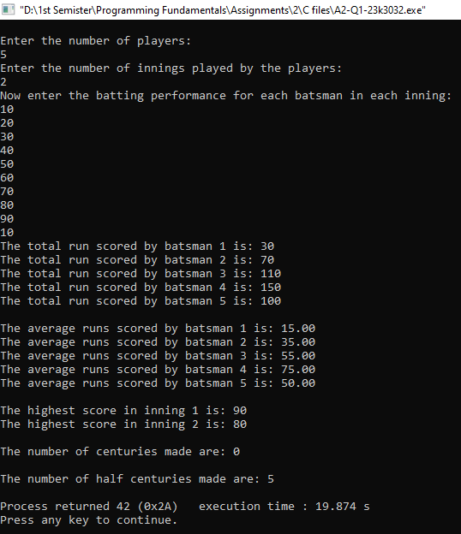**Output**

**Question:02**

**Code**

include<stdio.h>

#include<conio.h>

void main(void){

int rows,columns,i,j,max_square_size,max_square_row,max_square_column,x,y;

rows=columns=i=j=max_square_size=max_square_row=max_square_column=x=y=0;

printf("\t 23k-3032 SHAH HUNAIN\n\n\n");

printf("Enter the number of rows: \n");

scanf("%d",&rows);

printf("Enter the number of columns: \n");

scanf("%d",&columns);

int array[rows][columns];

printf("Input binary matrix '0's' and '1's' : \n");

for (i=0; i<rows; i++){

for (j=0; j<columns; j++){

scanf("%d",&array[i][j]);

}

}

printf("\n");

printf("Your input matrix is: \n");

for (i=0; i<rows; i++){

for (j=0; j<columns; j++){

printf("%d\t",array[i][j]);

}

printf("\n");

}

printf("\n");

for (i=0; i<rows; i++) {

for (j=0; j<columns; j++) {

if (array[i][j] == 1) {

int square_size = 1;

int is_square = 1;

while (i+square_size<rows && j+square_size<columns) {

for (x=i; x<=i+square_size; x++) {

if (array[x][j+square_size] == 0) {

is_square=0;

break;

}

}

for (y=j; y<=j+square_size; y++) {

if (array[i+square_size][y] == 0) {

is_square=0;

break;

}

}

if (is_square) {

square_size++;

} else {

break;

}

}

if (square_size>max_square_size) {

max_square_size=square_size;

max_square_row=i;

max_square_column=j;

}

}

}

}

printf("\nThe largest square submatrix of 1s is:\n");

for (i=max_square_row; i<max_square_row+max_square_size; i++) {

for (j=max_square_column; j<max_square_column+max_square_size; j++) {

printf("1\t");

}

printf("\n");

}

printf("\nThe dimension of the largest square sub-matrix is (%d x %d)\n", max_square_size, max_square_size);

}

**Output**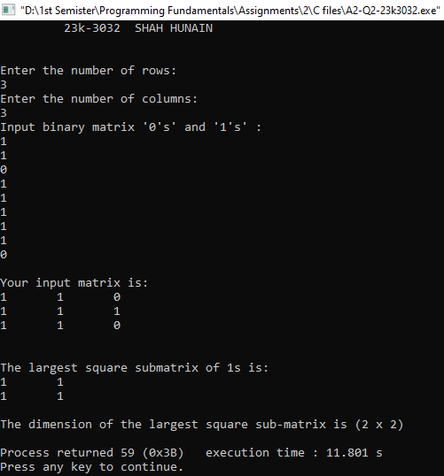

**Question:03**

**Code**

#include<stdio.h>

#include<conio.h>

void main(void){

printf("\t23k-3032 SHAH HUNAIN\n\n\n");

char days[5][20]={"MONDAY","TUESDAY","WEDNESDAY","THURSDAY","FRIDAY"};

int flightavailibility[5][4]={

{1, 300, 0, 0},

{1, 320, 1, 310},

{0, 0, 1, 280},

{1, 380, 0, 0},

{1, 375, 1, 400}

};

char time,day;

for (int i=0; i<5; i++){

for (int j=0; j<4; j++){

if(flightavailibility[i][0]!=0 || flightavailibility[i][2]!=0){

printf("The flight is available on day %s",days[i]);

printf("\n");

break;

}

else if (flightavailibility[i][0]==0 || flightavailibility[i][0]==0){

printf("The flight is not available on day %s",days[i]);

printf("\n");

break;

}

}

}

printf("\nThe highest probability of booking the flight due to availibility on both morning and evening is on: \n");

for (int i=0; i<5; i++){

for (int j=0; j<4; j++){

if (flightavailibility[i][0]!=0 && flightavailibility[i][2]!=0){

printf("%s\t\t",days[i]);

break;

}

}

}

printf("\n\n");

/*The traveler is flexible with the day of travel but prefers the morning time slot.

Determine the day(s) when a flight is available in the morning and suggest the best option for booking based on this preference.*/

printf("Choose the time slot you want: \n");

printf("M=Morning\tE=Evening\n");

time=getchar();

switch (time){

case 'M':

for (int i=0; i<5; i++){

for (int j=0; j<4; j++){

if (flightavailibility[i][0]!=0){

printf("The flight is available on %s and ticket price is Rs. %d\n",days[i],flightavailibility[i][1]);

break;

}

}

}

break;

case 'E':

for (int i=0; i<5; i++){

for (int j=0; j<4; j++){

if (flightavailibility[i][2]!=0){

printf("The flight is available on %s and ticket price is Rs. %d\n",days[i],flightavailibility[i][3]);

break;

}

}

}

break;

default:

printf("Invalid Input\n");

}

printf("\n\n");

printf("Now please enter the day on which you want to book your flight: \n");

printf("0=Monday\t1=Tuesday\t2=Wednesday\t3=Thursday\t4=Friday: \n");

fflush(stdin);

day=getchar();

switch (day){

case '0':

if (time=='M' && flightavailibility[0][0]!=0){

printf("The flight is available on %s and ticket price is Rs. %d\n",days[0],flightavailibility[0][1]);

}

else if (time=='E' && flightavailibility[0][2]!=0){

printf("The flight is available on %s and ticket price is Rs. %d\n",days[0],flightavailibility[0][3]);

}

else

printf("The flight is not available on %s\n",days[0]);

break;

case '1':

if (time=='M' && flightavailibility[1][0]!=0){

printf("The flight is available on %s and ticket price is Rs. %d\n",days[1],flightavailibility[1][1]);

}

else if (time=='E' && flightavailibility[1][2]!=0){

printf("The flight is available on %s and ticket price is Rs. %d\n",days[1],flightavailibility[1][3]);

}

else

printf("The flight is not available on %s\n",days[1]);

break;

case '2':

if (time=='M' && flightavailibility[2][0]!=0){

printf("The flight is available on %s and ticket price is Rs. %d\n",days[2],flightavailibility[2][1]);

}

else if (time=='E' && flightavailibility[2][2]!=0){

printf("The flight is available on %s and ticket price is Rs. %d\n",days[2],flightavailibility[2][3]);

}

else

printf("The flight is not available on %s\n",days[2]);

break;

case '3':

if (time=='M' && flightavailibility[3][0]!=0){

printf("The flight is available on %s and ticket price is Rs. %d\n",days[3],flightavailibility[3][1]);

}

else if (time=='E' && flightavailibility[3][2]!=0){

printf("The flight is available on %s and ticket price is Rs. %d\n",days[3],flightavailibility[3][3]);

}

else

printf("The flight is not available on %s\n",days[3]);

break;

case '4':

if (time=='M' && flightavailibility[4][0]!=0){

printf("The flight is available on %s and ticket price is Rs. %d\n",days[4],flightavailibility[4][1]);

}

else if (time=='E' && flightavailibility[4][2]!=0){

printf("The flight is available on %s and ticket price is Rs. %d\n",days[4],flightavailibility[4][3]);

}

else

printf("The flight is not available on %s\n",days[4]);

break;

default:

printf("Invalid Input\n");

}

}

**Output**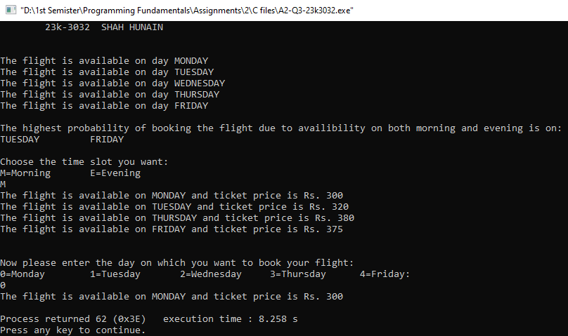

**Question:04**

**Code**

#include<stdio.h>

#include<conio.h>

void main(void){

char maze[5][5]={

{'S', 'O', 'O', 'W', 'W'},

{'O', 'W', 'O', 'W', 'W'},

{'W', 'O', 'O', 'W', 'O'},

{'W', 'W', 'O', 'W', 'O'},

{'W', 'W', 'O', 'E', 'W'}

};

int i=0,j=0;

printf("\t23k-3032 SHAH HUNAIN\n\n\n");

while (1){

if (maze[i][j]=='S' || maze[i][j]=='O'){

printf("%d,%d ",i,j);

j++;

}

else if (maze[i][j]=='W'){

j--;

i++;

}

else if (maze[i][j]=='E'){

printf("%d,%d ",i,j);

break;

}

}

}

**Output**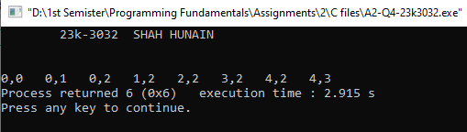

**Question:05**

**Code**

#include<stdio.h>

#include<conio.h>

void main(void) {

int n;

int sum1=0, sum2=0;

printf("\t23k-3032 SHAH HUNAIN\n\n\n");

printf("Enter a number of how many to find Ramanujan-Hardy Numbers : \n");

scanf("%d", &n);

for (int i = 1; i <= n; i++) {

for (int j = 1; j <= n; j++) {

for (int k = 1; k <= n; k++) {

for (int l = 1; l <= n; l++) {

sum1 = i * i * i + j * j * j;

sum2 = k * k * k + l * l * l;

if (sum1 == sum2 && i != j && i != k && i != l && j != k && j != l && k != l) {

printf("Ramanujan-Hardy Number: %d = %d^3 + %d^3 = %d^3 + %d^3\n", sum1, i, j, k, l);

}

}

}

}

}

}

**Output**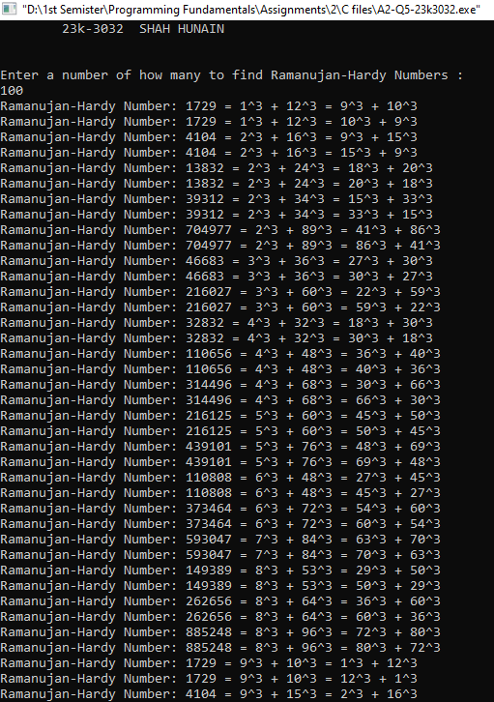

**Question:06**

**Code**

#include<stdio.h>

#include<conio.h>

void main(void){

int size,t;

size=t=0;

printf("\t 23k-3032 SHAH HUNAIN\n\n\n");

printf("Please enter the size of the array: \n");

scanf("%d",&size);

int arrayN[size];

printf("Now enter the elements of the array: \n");

for (int i=0; i<size; i++){

scanf("%d",&arrayN[i]);

}

printf("Now enter the target sum: \n");

scanf("%d",&t);

for (int i=0; i<size; i++){

for (int j=i+1; j<size; j++){

if((arrayN[i]+arrayN[j])==t){

printf("%d , %d ",arrayN[i],arrayN[j]);

}

}

}

}

**Output**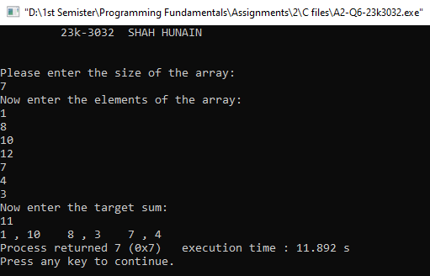

**Question:07**

**Code**

#include<stdio.h>

#include<conio.h>

void main(void){

int numberofshirts,numberofages,numberofprices;

numberofshirts=numberofages=numberofprices=0;

printf("\t23k-3032 SHAH HUNAIN\n\n\n");

printf("Enter the number of shirts: \n");

scanf("%d",&numberofshirts);

int array1[numberofshirts][2];

printf("\n");

for (int i=0; i<numberofshirts; i++){

printf("Enter the age and price for %d shirt: \n",i+1);

for (int j=0; j<2; j++){

scanf("%d",&array1[i][j]);

}

}

printf("\n");

int temp;

printf("The Sorted list in ascending order with respect to Age is \n");

for (int i=0; i<numberofshirts; i++){

for (int j=0; j<numberofshirts-i-1; j++){

if(array1[j][0]>array1[j+1][0]){

temp=array1[j][0];

array1[j][0]=array1[j+1][0];

array1[j+1][0]=temp;

}

}

}

for (int i=0; i<numberofshirts; i++){

printf("%d ",array1[i][0]);

}

printf("\n");

printf("The Sorted list in descending order with respect to Price is \n");

for (int i=0; i<numberofshirts; i++){

for (int j=0; j<numberofshirts-i-1; j++){

if(array1[j][1]<array1[j+1][1]){

temp=array1[j][1];

array1[j][1]=array1[j+1][1];

array1[j+1][1]=temp;

}

}

}

for (int i=0; i<numberofshirts; i++){

printf("%d ",array1[i][1]);

}

printf("\n");

}

**Output**